ANNUAL REPORT
2015

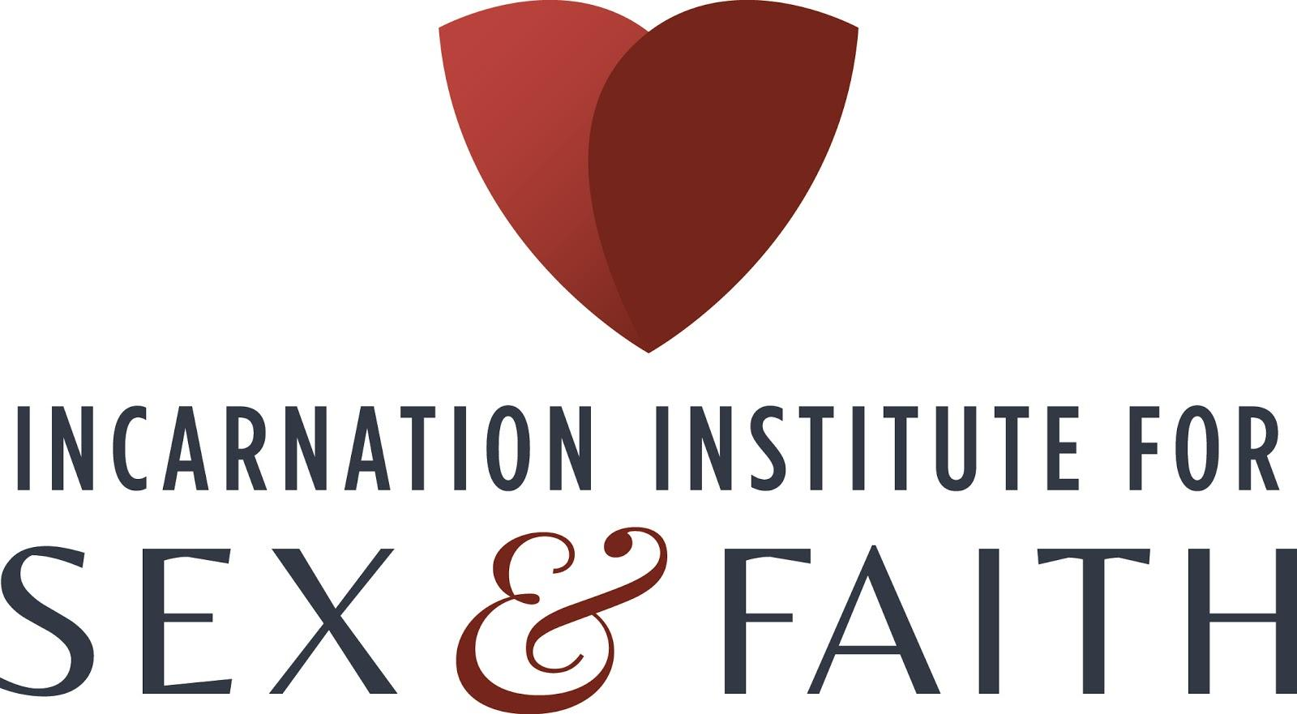
From the Founder
Friends,

It is always amazing to review the calendar, and discover how much activity one can pack into 12 months! And, in this report, you will see that this year was busy! This, in combination with the anecdotes we hear, reveals how much our work impacts people’s lives. One person, who is not a Christian but well acquainted with this work, now finds himself correcting people when he hears them bad-mouthing Christianity. “Check out the Incarnation Institute for a different view.” he says! Another person, obviously relieved, said, “I never knew so much of these negative ideas (about sex) came from church fathers, instead of the Bible.” Another phrase we like to hear is, “I never thought of it like that before.” We are bucking 1700 years of sex-negativity in the church and culture; it is a humbling experience as well as a true privilege to be a catalyst for transforming people’s lives!

Our focus for this year was threefold: to 1) continue increasing the organizational visibility in the media and through our advisory team, 2) develop our educational mission more fully and, 3) search for financial partners. As you can see we have made substantial progress toward achieving these goals.

This 2015 annual report describes this first full year of our efforts to reinsert the humanity of “Son of Man” back into the Christian teaching and to help people see the connection between God becoming flesh and our own intimate lives. Enjoy!

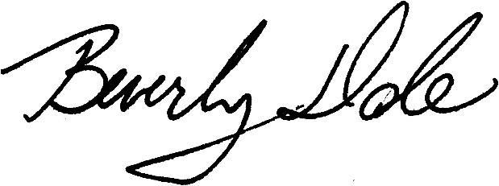

Rev. Dr. Beverly Dale
Founder and Executive Director

Mission

Our mission is to teach people to love their bodies (and the bodies of others) like God does. To do this we provide programming that teaches an inclusive, science-friendly, and sex-positive Christianity. This is based on the following truths that are consistent with biblical teaching and sound theological reasoning:

- Sexual diversity is a natural trait to be celebrated.
- Sexual pleasure is a sacred gift to be treasured.
- Sexual freedom is a human right to be personally discerned and morally exercised.

___________________________________________________________________________
“This workshop [entitled “Deconstructing Christian Erotophobia”] is the only reason we came to this conference.”
A United Methodist couple finding marital satisfaction in alternative sexuality
____________________________________________________________________________________

Our roots

We unapologetically draw our moral guidance from the Bible, but always keep it in dialogue with reason and the intellect. We are informed by scientific understandings of what it is to be a healthy sexual human capable of fulfilling intimate relationships, even as we also honor personal spiritual discernment as an appropriate guide for sexual decision-making. As we focus on sex-positivity, we are also grounded and firmly rooted in the Christian values of righteousness and justice. We are guided by some of the great thinkers in the Christian tradition:
- “The word became flesh and dwelt among us.” - John 1:14
- “Every creature participates in some way in the likeness of the divine essence.” -Meister Eckert, Christian mystic
- “God is in our sensuality, for in the same instant and place in which our soul is made sensual… exists the city of God.” - Julian of Norwich, Christian mystic
- “The soul is not in the body; the body is in the soul.” - St. Hildegard of Bingen
- “I say you are Gods, children of the most high, all of you.” - Psalms 82:6

Board

The women-centered Oversight Board continues to be chaired by the Rev. Dr. Beverly Dale, the Founder. It includes an artist, and sexuality graduates or current students, all of whom have been or currently are affiliated with the Christian Church. We are diverse in sexual orientation, race, and age. Three new members were added this year. (marked with an *)
- Alexandra Day, Secretary
- Rachel Keller, Treasurer
- Jennie Brogan, Social Media*
- Christin Holy, Development and Grant Writing*
- Lynette Medley, Diversity Coordinator
- Arial Moore, Website*

Administration

Until a national board is developed, current members of the Oversight Board act as volunteer staff in the workings of the organization. And, while we prefer to focus on the programming and our mission’s goals, the administrative needs of the organization must also be met. To that end, this year we are proud to have accomplished the following technological feats:
  - Migrated to a different website system
  - Implemented and conducted a webinar/conference system
  - Developed an electronic newsletter format
  - Incorporated the usage of powerpoint materials in the webinars
In addition, we continue to maintain contact with two seminaries in preparation for partnerships, as we move toward developing an educational program for sexology and theological professionals. ___________________________________________________________________________
“Your spirit and challenge opens the windows and doors for so many people to know that God is love!!!”
Franklin & Marshall College Chaplain
___________________________________________________________________________________

GOAL #1: INCREASE ORGANIZATIONAL VISIBILITY

Advisory Team

Our advisory team is composed of nationally and internationally recognized scholars and practitioners in the disciplines of theology and sexology. Their primary task will be to advise on curriculum development. Joining us this year are three new members. They are:
- Rev. Dr. Kelly Brown Douglas – a body-centered theologian and womanist whose work focuses on the ways black bodies are viewed by the black church and in wider community, and the profound impact this has personally, relationally, as well as societally.

- Dr. Miguel De La Torre – a Cuban theologian whose work focuses on the continuing legacy of the political, economic, and social impact of colonization, and the marginalization of those persons – including sexuality.

- Rev. Chris Glaser – a well-known author who was one of the early gay men to challenge the Presbyterian Church on its exclusionary ordination policies. He subsequently was ordained in the ministry as a clergy in the Metropolitan Christian Church and is the author of numerous books, primarily for members of the sexual minority communities.

They join our other advisory team members:
- Dr. Michele Angello – an internationally known therapist specializing in gender variant
youth.
- Rev. Dr. Katie Day – a theologian and sociologist specializing in economic justice and racial
disparities.
- Rev. Dr. Marvin Ellison -- a theologian specializing in ethics particularly sexual ethics,
women’s reproductive justice and lgbt rights.
- Dr. Kenneth Maguire - a therapist and contributor to the national media on matters of
sexuality and intimacy.
- Rev. Dr. Joan Martin - a theologian focusing on reproductive justice, anti-racism, and
interfaith justice movements.
- Dr. Virginia Ramey Mollenkott – a renowned author of numerous books that challenge the
Christian church to seek body justice especially for sexual minority communities.
- Dr. Kate Ott – an ethicist writing extensively about sexuality and faith and focusing on youth
and curricula for the general public and seminary training.
- Chris Paige – a national advocate and community organizer for sexual minority
communities, specifically trans and intersex whose interfaith work includes attention to
anti-racism and sexual justice.
- Rev. Dr. William Stayton – a well-known sexologist and pastor who works at national and
international levels of the church to advise and train professionals in both fields.
- Dr. Beverly Whipple – known for her ground-breaking research on the g-spot, she has
taught nursing professionals and sexologists in national and international audiences.

____________________________________________________________________________
“I want to thank you from the bottom of my heart for… your wonderful message about self-pleasure…Your interpretation of God's desire for us to experience pleasure is refreshing and liberating.” RN
____________________________________________________________________________

2015 Media Attention

In addition to formal programming, IISF continues public outreach on several fronts: the website, YouTube videos, webinars. This resulted in local and international media attention. The interviews include the following:

- Sexologist Martha Lee of Eros Coaching, from Singapore called, “Exploring God as Eros.”
- Blogger, Heather Harvey of Awkrotika.com\
- Publisher Cynthia Spence of Sensheant magazine Issue #4 (Forthcoming)
- Rachel Bussel Kremer Philadelphia City Paper, “The Rev. Beverly Dale embraces sex —
and God” July 2, 2015
- Podcaster, Timaree Leigh “Can You Be a Christian and Pro-Sex?”

GOAL#2: DEVELOP OUR EDUCATIONAL MISSION

2015 Accomplishments

This year marks the conclusion of our first complete year of operation. It was in May 2014 that IISF received the official notice from the IRS that we had 501(c)(3) status. This made us eligible for financial support and tax-deductible donations from individual supporters. We were able to take advantage of this exemption and attract our first foundational support. In partnership with the United Christian Church of Levittown, we received a grant from the Carpenter Foundation. This grant provided the budget to more fully develop the curriculum we first presented last year, which was geared toward the general public. This financial assistance, combined with our first crowdfunding efforts and the continued gifts and donations from friends and supporters, has made for an amazing first year. Some of our accomplishments include:

- Wrote, developed and produced four webinars
- Conducted our first crowdsourcing initiative
- Developed a 5-minute video for our website
- Held workshops at six national conferences
- Gave five programs in other settings
- Advanced our technological skills

2015 Programs

Our long-range mission is twofold: first, to provide much-needed sexological and theological education for professionals in those respective fields. (This was the focus for this year’s crowdfunding initiative). And second, to provide educational resources to the wider community, especially those who have either personal or career interests in healthy, intimate relationships. IISF has already begun providing inclusive, science-friendly, and sex-positive educational Christian programming for the latter, usually in a one-time program format. These sessions provide groups and individuals with a preview of our training programs. The presentations included:

•Five one-time programs. They were:
  - Swarthmore College “Faith Intimacy and Sexual Decision-making: An Interactive
Discussion”
  - Franklin and Marshall College: “You can have: Faith, Intimacy and Sex”
  - Happy Hour with a purpose (The Charge Station) Topic: Sex Positive Bible Bingo
  - Presbyterian Church, Lawrenceville, NJ Topic: "Using the Bible to Find Good News About the
Body"
  - Meet-Up NJ Topic: “Christianity and Polyamory: It’s not Either/Or”
  - Webinar series “Reading the Bible with Sex-Positive Eyes.” We had twenty participants who
virtually joined us (or listened later) for four 1 ½ hour sessions in Oct. and Nov. Archives of
these sessions will continue to be available for purchase through our website. The titles are:
    - Intro to the Bible & Sex-Negativity
    - Discerning Truth, Discerning Culture
    - Sex in the Bible: the Good, the Bad, & the Ugly
    - Sex: How? When? Under What Circumstances?

- Conference presentations included:
  - Loving More Polyamory – for those in alternative lifestyles, PA - February
“Sexual Decision Making made Easy (easier) with Faith Principles”
  - Catalyst Con East – for activists and professionals in field of sexuality, VA - March
“Deconstructing Christian Erotophobia”
  - AASECT- for sex educators, therapists and counselors, MN -June
“Sex Positive and Faithful: Finding the Middle Ground”
  - Woodhull Sexual Freedom Summit – for sexual freedom activists, VA - August
“Sexual Freedom and Christianity: Dismantling the Hostilities”
  - Transcending Boundaries- for sexual minorities, MA- November
“Toward Diversity and Freedom by Deconstructing Christian Erotophobia”
  - National Sex Ed – for sex educators, NJ- December
“Deconstructing Christian Erotophobia for Better Sex Ed”

As a Clergy-in-Residence at the United Christian Church, a Disciples of Christ and United Church of Christ combined congregation, in Levittown, PA, Rev Bev has preached 12 sermons this year. Some of these are currently available on the YouTube channel Rev Beverly Dale.
Sex-Positive sermons include:
- Love Stories & Dysfunctional Families, an examination of dysfunctional relationships in the Bible and in ourselves, how to discover the real love story.

- Breaking Open Our Hearts & Opening Our Eyes, an examination of race and how different bodies are treated, the need for the National Day of Repentance (called by AME Church Bishops)

- The Balm that Heals, a look at the American church’s involvement in the “kill the gay” bills in parts of Africa, and the need for repentance on Gilead Sunday (an initiative of the Religious Institute)

- Sacred Lived Moments: Bread, Belief, Beloving, opening our eyes to God moving in our lives, entering the suffering of others so we might leave a trace of Jesus behind

- When Mother Rules, a spiritual celebration of Mother’s Day, that removes gender and procreation as necessary prerequisites

- A Veiled Gospel Truth: God as Erotic Passion. A look under the veil of Christianity, finding God as the Divine Erotic

- Love Chooses the Disempowered; Sheep and Shepherds, You and Me. Luke’s nativity story tells that love is found at society’s margins, with the disempowered: trans people, sex workers, the poor, and sexual and racial minorities

- Raw, Cooked, on Fire Understanding Hannah’s gift to God of her son through the eyes and passion of the Sufi mystics we remember to live passionately - not in our heads - but our bodies.

GOAL #3: SEARCHING FOR FINANCIAL PARTNERS

FINANCIAL REPORT
Income

We implemented our first crowdsourcing initiative for our training and were pleased to attract over twenty donors, most of whom we didn’t even know. In addition, a new partnership with the Carpenter Foundation and the United Christian Church of Levittown allowed us to do more than we had envisioned programmatically. Not only did we design a curriculum to use with the general public, but we presented it as a 4-session webinar. Our income came from the following sources:

Individual 30 %
Grant 60 %
Non-Profit 10 %

Expenses

This year, we were able to significantly increase our programmatic expenses due to the foundation grant that underwrote it. The bulk of our efforts focused on developing, promoting, and hosting the webinar series. We also utilized travel funds associated with conference and workshop presentations, and administrative resources to develop our promotional materials.

Administration 9 %
Program 80 %
Development 11 %

______________________________________________________________________________
“I found your presentation absolutely refreshing and uplifting! I found myself asking,
‘Where have you been?!’ ” ☺ KB ________________________________________________________________________________________

ON THE HORIZON FOR 2016

Building on the successes of this year, we invite our supporters and partners to help us achieve our goals for next year.
Our programmatic goals for 2016 include:
a) hosting a regular “chat” online to discuss sexual and/or faith-related concerns
b) offering the webinar series again in the fall, with improvements including a study guide for participants

Our organizational goals include:
a) adding theologically trained specialists to our Oversight Board
b) developing an informal structure that facilitates dialogue between sexological and theological professionals
c) pursue financial funding for the training seminar for professionals

In addition, Rev. Dr. Beverly Dale will be an adjunct professor at Lancaster Theological Seminary during the spring term. She will teach the sexuality and religion course: Ministering in Matters of Human Sexuality.

THANK YOU to our Partners!!!
(updated 12/25/15)
$15,000
Carpenter Foundation

$2,000-$14,999
Tabernacle United Church

$501-$1,999
Anonymous
Rev. Dr. Beverly Dale
$250-$500
Dr. Ken Haslam
Rgt. Rev. Edward Lee
Linda McGowan
Lynette Medley
Jim Turner, Esq

$100-$249
Vic Compher
Alexandra Day
Linda DeHart
Christin Holy
Anita Illig
Rachel Keller
Fred Matt
Arial Moore
Rev. Ralph Moore
Susan Pierce

Under $100 (cont’d)
Alan MacRobert
Amy Mann/ Jean Erb
Carl McHenry
Holly Phares
Christopher Purdom
Dr. Mark Rader
Max Rivers
Dr. Larry Singh
Dr. Al Vernacchio

Under $100
Amanda Ainscough
Jennie Brogan
Minister Jim Cavenaugh
Erin Crabill
Dan Eldridge
Dr Marvin Ellison
Rev. Elizabeth Ellis
Hardy Haberman
Paul Heatley
George Herold
Nancy Krody
Don Little

